

Pirates Trading Post

Verion2



October 2, 2019

Thomas J. Short

Cis 260-01

**Pirate Trading Post Results**

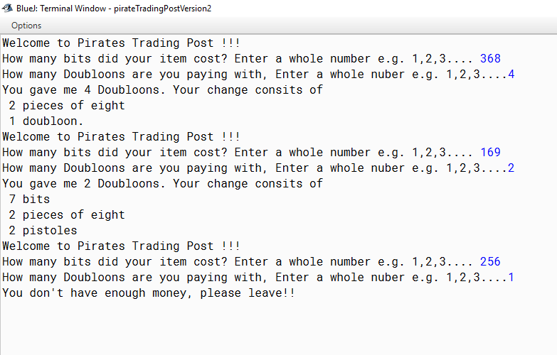

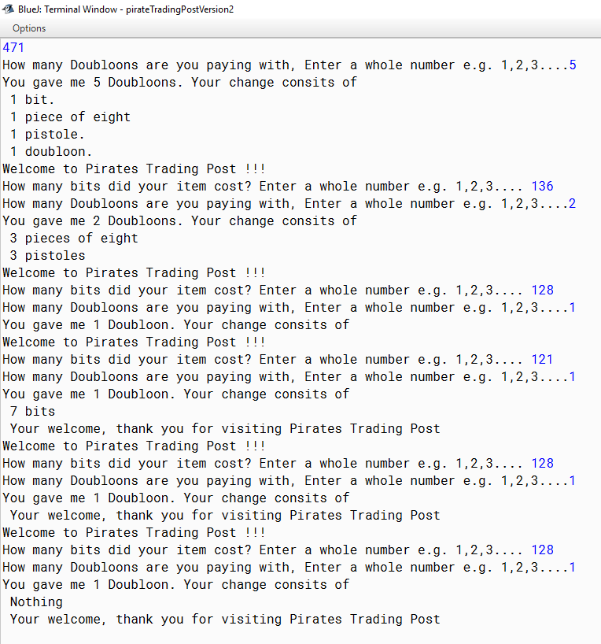**Pirate Trading Post Results**

**Test Set pirate**

|  |  |  |  |
| --- | --- | --- | --- |
| input | Expected  output | output | Rational |
| 471, 1 | 1 bit  1 POE  1 pistole  1 doubloon | 1 bit  1 POE  1 pistole  1 doubloon | All Single results |
| 128, 1 | 0 | 0 | No change |
| 368, 4 | 2 pieces of 8  1 doubloon | 2 pieces of 8  1 doubloon | Single and  plural |
| 169, 2 | 7 bits  2 pieces of eight  2 pistoles | 7 bits  2 pieces of eight  2 pistoles | All plural results |
| 256, 1 | Not enough | You don’t have enough please leave | Checking the if statement |
| 128, 1 | No change | Your change consists of nothing | Display no change |